Contact: Nancy Terry, Executive Director
info@powersweeping.org | (888) 757-0130

Synopsys:
The Situation: Public and front-line government workers are not familiar with the language surrounding public works projects. Commonly when the terms “sanitation” or “solid waste,” are used, workers such as enforcement officers do not think sweepers and trash trucks. This poses substantial hindrance to the much-needed work of Power Sweepers.
The work performed by this sector of business is critical to the health and safety of human life as well as is critical to our environment for many reasons including the following examples:
- Unswept surfaces collect used masks and gloves which will multiply creating a new health risk
- Stormwater and urban runoff will worsen from the toxic debris washed into the watershed and waterways
- Air pollution will worsen from toxic dust particles (PM-10 fugitive dust)
The Solution: Add the universal terms of “Power Sweeping” to the list of essential services.

Letter: Government Agency

[Insert Governor/Mayor Name, Title, Address]
Dear Governor, __________________:
I want to extend my appreciation towards you and your staff for the tireless work you have demonstrated in interpreting and addressing the CISA Guidelines that provide a framework for establishing “Essential Services” within our state. Working with the North American Power Sweeping Association (NAPSA), we are being proactive in helping inform the public in universal terms that “Power Sweeping” is classified under transportation, public works, sanitation, and solid waste as an essential service.
During normal times, the Power Sweeping industry is 24 hours per day, 7 days per week on the front lines keeping our roadways and paved surfaces safe for the public and environment. Currently that has been enhanced with the unprecedented increase in masks, gloves and wipes now discarded on the ground (see example attached). Surprisingly many of our customers, local officials, and the public are not aware of our services and critical benefits to the health of our communities and the environment which fall under the above classifications.
We urge you to instruct staff to include universal language when providing lists of essential services and add the term “Power Sweeping”. This will substantially assist in our ability to collect and properly dispose of the hazardous discarded masks, gloves, and wipes we encounter every shift. Additionally, we can continue to protect the water systems, stormwater, urban runoff, by removing toxic debris and dust (PM-10 fugitive dust) which is critical in maintaining air quality and the environment.
When publishing directives, merely using the universal terms of “Power Sweeping” and “Trash Removal “will help alleviate the current confusion and ensure our industry can continue to perform its essential function.
I greatly appreciate your time in receiving and considering my message.
We are in this together! Be Safe, Stay Healthy!
Best regards.

President/Owner
PS: ANSI has designated NAPSA as the organization tasked with writing, publishing, and updating the national power sweeping standards.
PSS: Additional comments regarding Power Sweeping as an essential service for the ongoing health of our communities is attached.

Public Works projects, services, employees and contractors are dedicated to delivering life sustaining services that positively impact the environment and quality of life for the general population, with a particular focus on improving the quality of the air we breathe and the water we drink.
BELOW: Power Sweeping truck
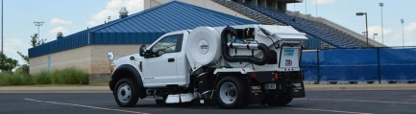

Within these initiatives is an integral component dedicated to keeping construction projects clean, highway projects more productive, storm water runoff from municipal streets, state highways and commercial parking lots clean while minimizing fugitive dust. I am speaking about the seldom recognized and predominantly mis-understood role that power sweeping contractors play in the health and safety of our communities, that is as critical a function as sanitation services removing curbside trash from residential areas. Sweeping contractors remove the trash and garbage that doesn’t make its way to a container but is on streets, highways and commercial areas. Due to the nature of this process, Power Sweepers naturally social distance with typically one employee per unit.
Power Sweeping is an EPA – BMP
BELOW: Discarded masks, gloves and wipes are picked up each shift by Power Sweeping companies.
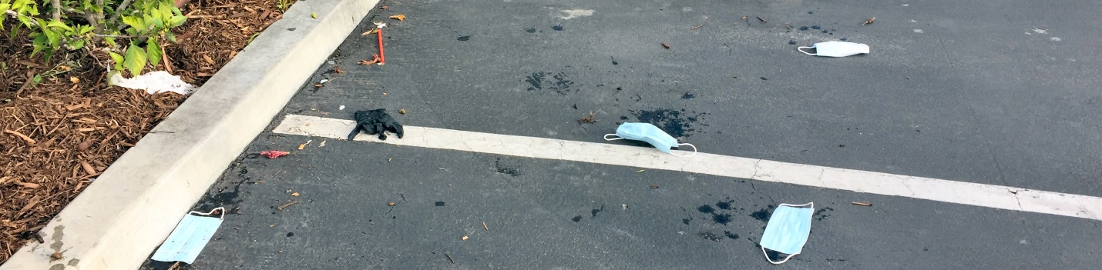

BELOW: Typical trash being removed
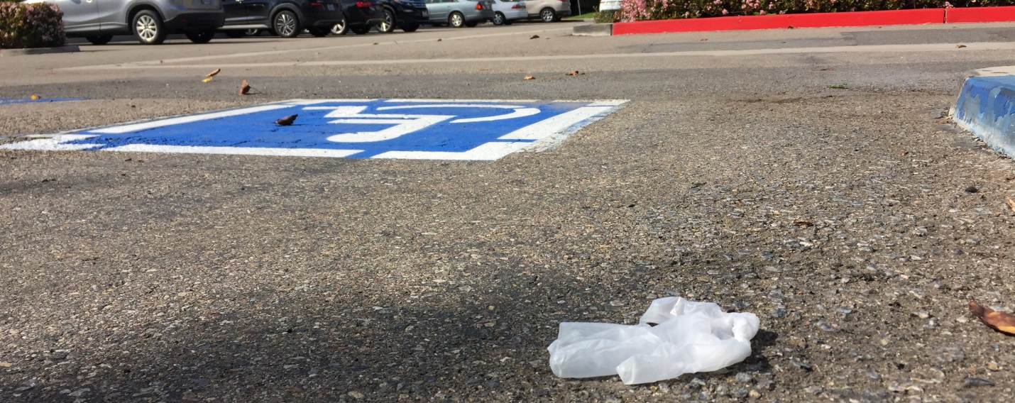

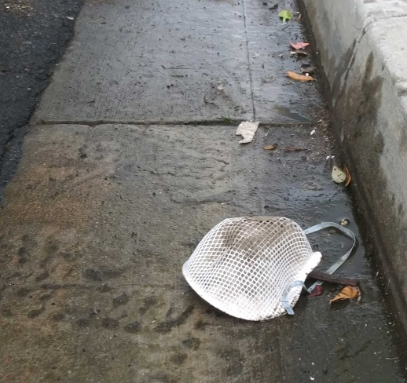
BELOW: Power Sweeping truck and broom
